**Project Title:** Protein Store

1. **Description:**

An ecommerce for Protein Store in Nablus, which is a protein supplement store, we sell proteins, herbs, vitamins and minerals, creatine, pre workout and others. The website is meant to deliver supplements to the Westbank and other cities in the occupied portion of Palestine if possible.

This project is a requirement to pass (Team Project-1) in An-Najah National University (CAP).

1. 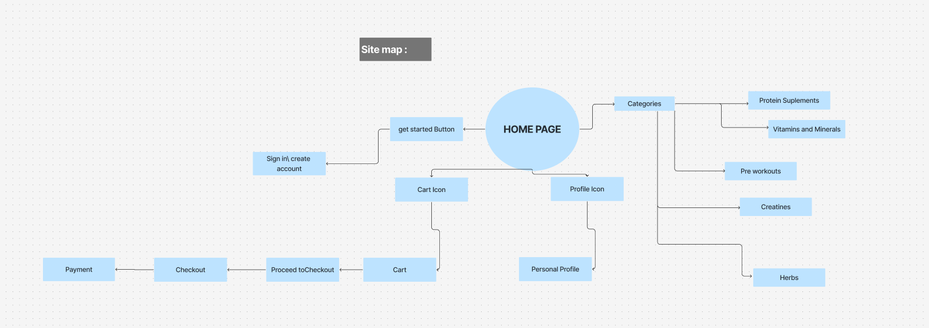**Site map**
2. **Features**

* Stored data of cart/items/user information in firebase database
* Only admins can control and manage items added and removed.
* Multiple Payment methods.
* Simple design and simple use.
* Can view website as a guest.

1. **How to run project**

* Clone the repository to your device by the following command.

git clone <https://github.com/Web1-Teams/930am-grp2-repo.git>

* Go to the folder that you cloned the repository in and open a cmd and type code . to open VS code without project in it.
* Since we are using firebase data base, font awesome and routes make sure to download the following:

1. npm install react-router-dom
2. npm install firebase
3. npm install @fortawesome/fontawesome-free

* Once you are done with all that you can write "npm start" to run the website on a localhost.

1. **Trello Link**

<https://trello.com/b/7INotFip/protein-project-management>

1. **Fegma (UI Design)**

<https://www.figma.com/design/UArdwnJjYjm1MF4Xc2Pjzo/protein-project-wire-frame--Tasbeeh?node-id=0-1&p=f&t=i2WJ8lmJZkaoDAOI-0>

1. **More Details**

The main goal of the website is to help the users find the suitable products, easily where ever they in Palestine, giving them more details and descriptions, easier and variable. It will help us in to deal with a huge number of customers, there’s professional assessment.

* 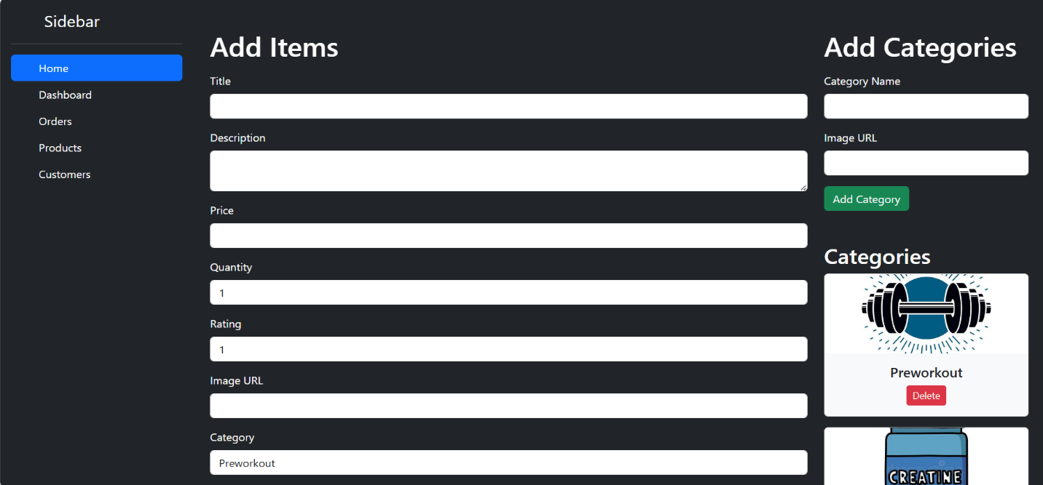**Admin Pages**

* 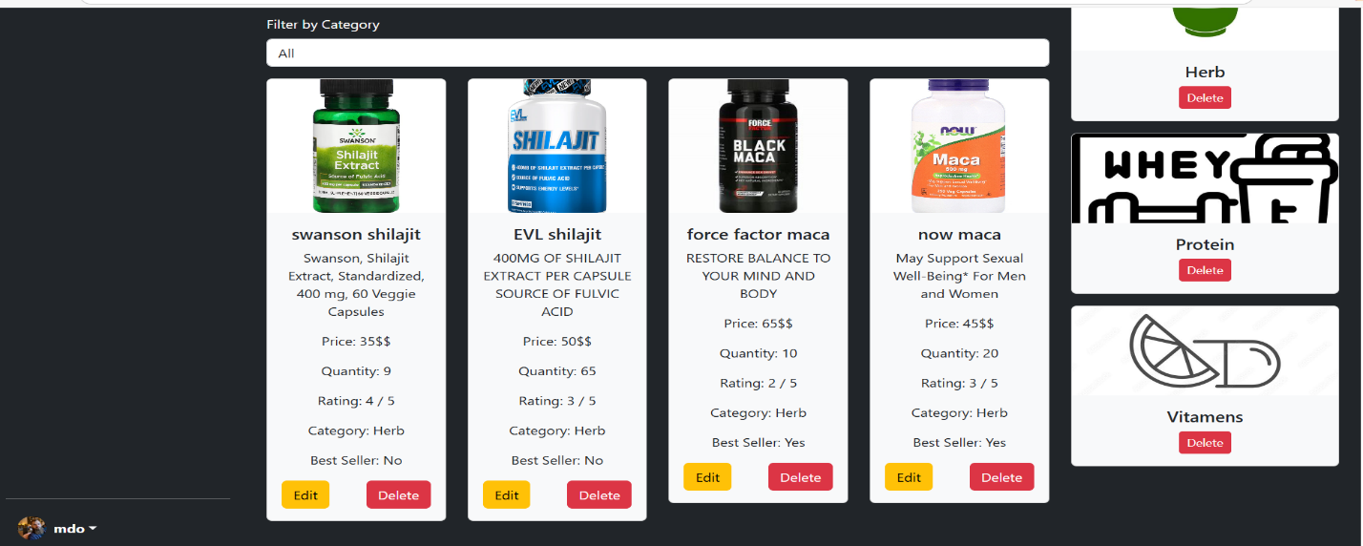**Cards**
* 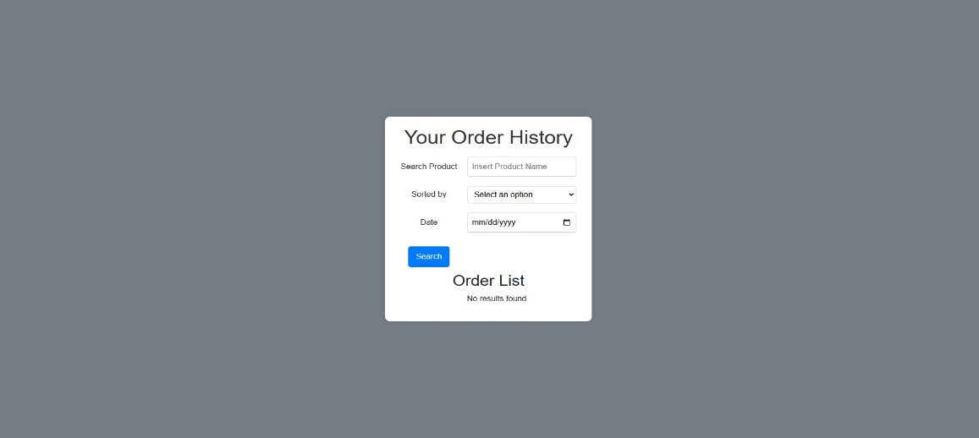**Purchase History**
* 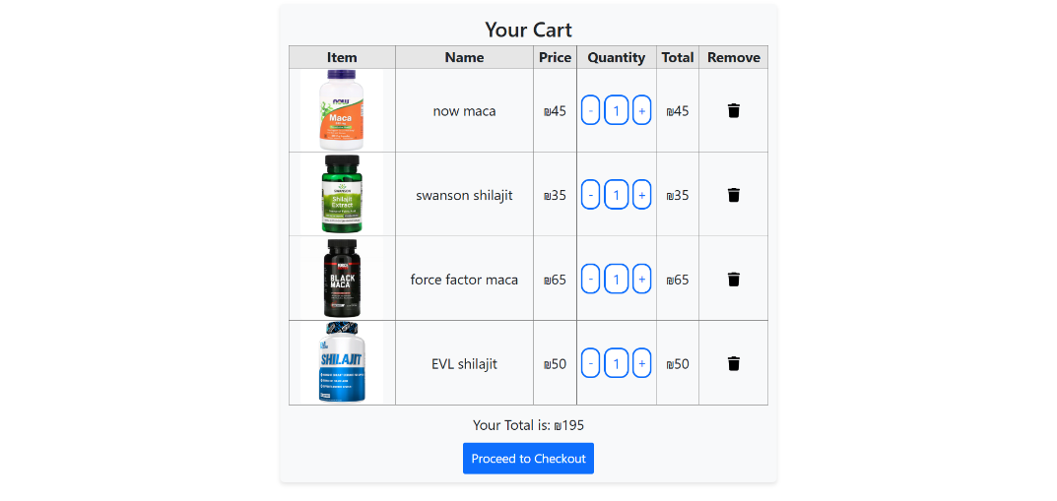**Cart**
* 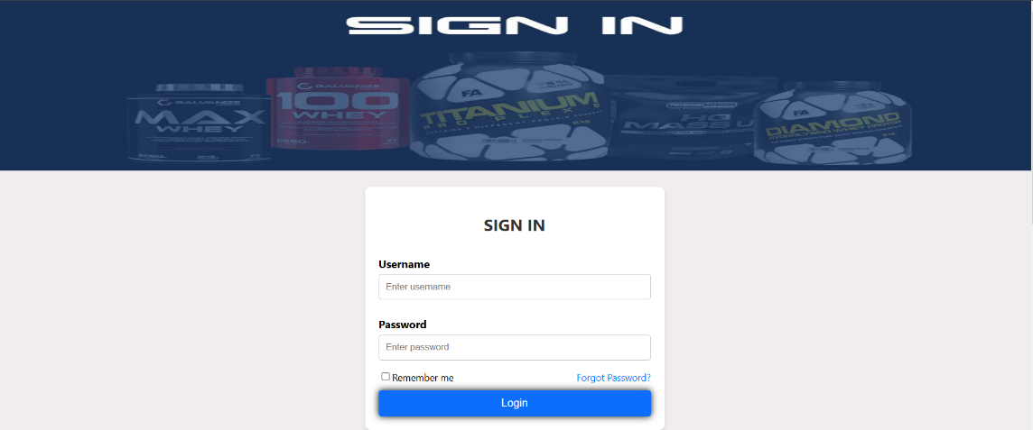**Create Account and Login**

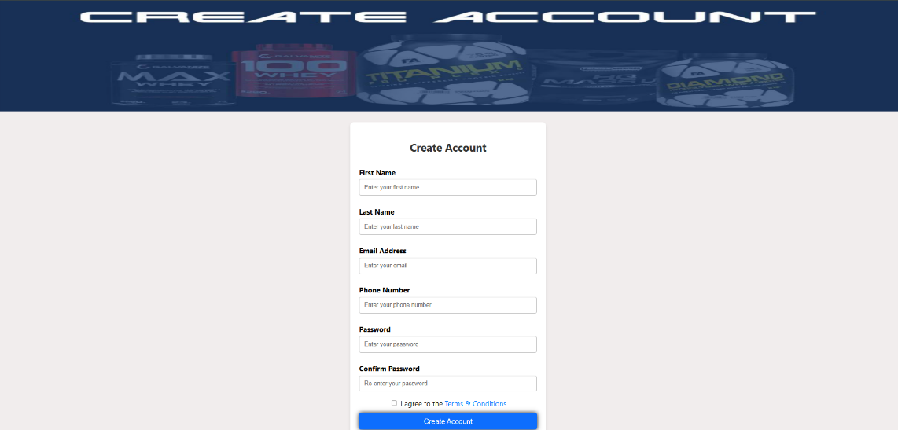

* 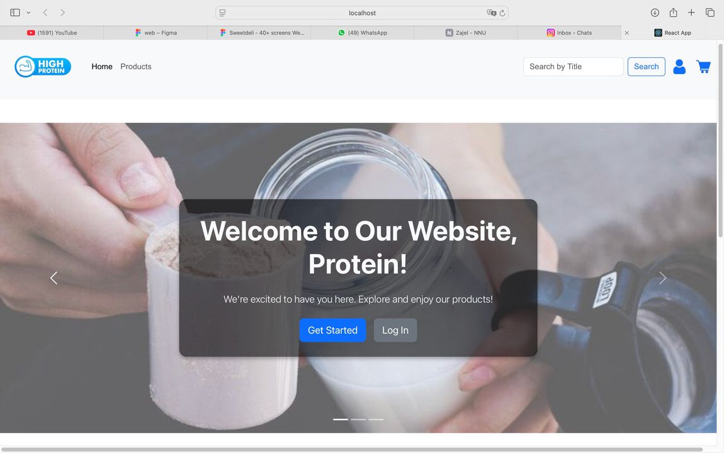**Main Page**

